 | MAIN SPONSORS    World Space Week  4 – 10 October 2004  www.space.gov.za/wsw/  The theme for World Space Week 2004  "Space for Sustainable Development"  Dept of Science and Technology    SAASTA    -----------------------  COMMERCIAL SPONSORS      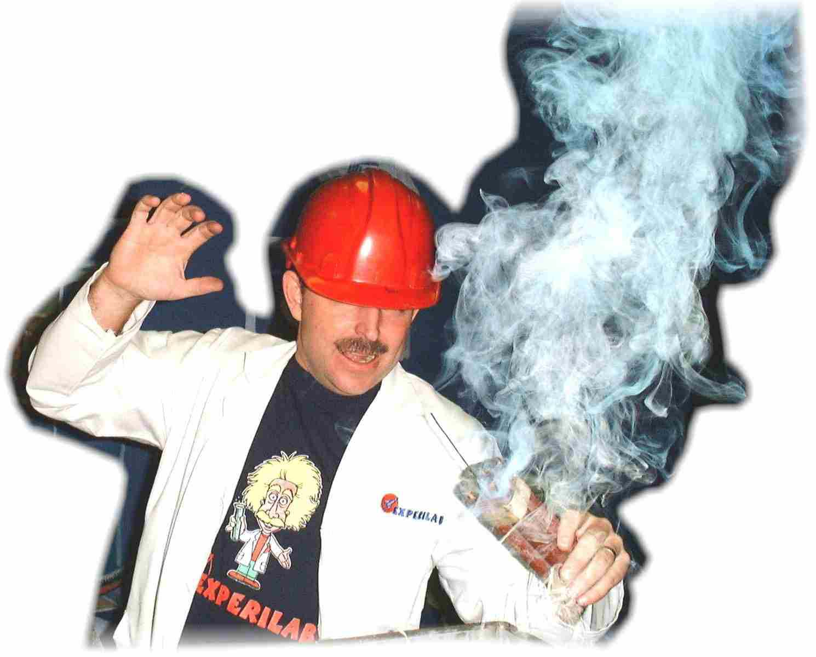            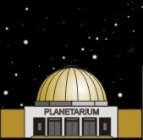
  
  A TELESCOPE & ASTRONOMY EXPO
  WHEN: | Saturday 24 April 2004
  WHERE: | National History Museum (aka War Museum), behind the Joburg Zoo
  ENTRANCE: | R10 for adults, R5 for children and senior citizens
  FORMAT:
  We are very fortunate to have several eminent presenters for the day.
  The theme for the auditorium talks is: 'Life in the Universe'.
  Come join the big debate on “Are we Alone?”
  Amateur telescope makers will exhibit self-built equipment and may enter the Amateur Telescope Making (ATM) competition. They will be available to explain their designs and provide specialist advice on build/buy options.
  Contact us if you want to exhibit.
  Our commercial exhibitors will show off and sell equipment such as telescopes and accessories, cameras and books and be on-hand to answer your questions.
  The ATM class members will conduct mirror-grinding demonstrations, and explain the principles of making your own reflector telescope.
  Experilab's MAD SCIENCE Shows to entertain young and old with the wonders of science.
  Throughout the day there will be interactive workshops on building an elementary telescope and how to use a planisphere.
  PCs will be available to surf astronomical websites around the world.
  Astrophotography competition and display.
  Bring your photos to be judged and win a spotting scope and tripod.
  (Rules are on the website)
  Experienced amateur telescope makers will lead visitors through a guided tour of the outside exhibits. This will be followed by a Q&A session, aimed at educating and entertaining visitors whether they already own telescopes or are considering buying/building one.
  All visitors can enter our Raffle (R5) and win binoculars, Science Pack, etc.
  STAR PARTY from 6pm
  Telescope owners and our commercial sponsors will have telescopes available, through which you can see the Moon, Saturn and other objects (weather permitting). You are welcome to bring a picnic to enjoy on the lawns.
  SEE EVENT SCHEDULE (Chris make hyperlink to EVENT SCHEDULE, FLYER and POSTER)
  Have a look and print FLYER
  Have a look and print A4 POSTER
  More info needed? Contact: lerika@icon.co.za

