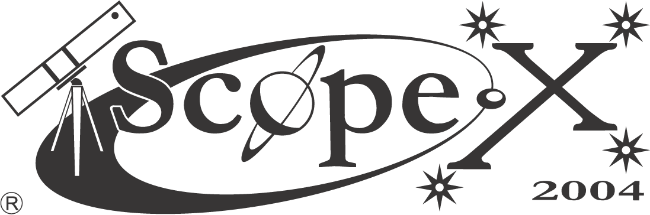 | Telescope & Astronomy Expo

Interested in astronomy, sky gazing, the Universe, buying/building a telescope, astrophotography?
_____________________________________________________________________________

WHEN | Saturday 24 April 2004
WHERE | National History Museum (aka War Museum), behind the Joburg Zoo
ENTRANCE | R10 for adults, R5 for children and senior citizens

- Talks on ‘Life in the Universe’. Come join the big debate on ‘Are we Alone?’;

- Exhibits of self – built and commercial telescopes including a guided tour through the exhibits aimed at educating and entertaining;

- Mirror-grinding demonstrations to explain principles of making your own reflector telescope;

- Mad Science Shows, interactive workshops on building an elementary telescope and how to use a planisphere;

- Astrophotography competition – win a spotting scope and tripod.

STAR PARTY from 6pm
Tour the night sky through a telescope, bring a picnic and join us!

FOR EVENT SCHEDULE AND MORE INFO: WWW.ASSAJHB.CO.ZA
_____________________________________________________________

