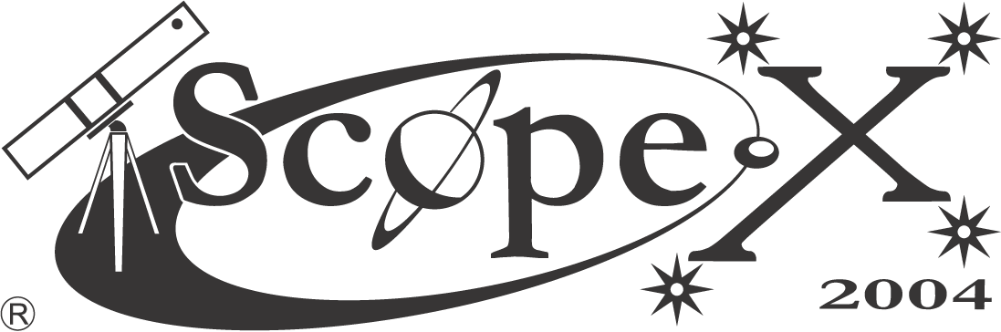
TELESCOPE & ASTRONOMY EXPO

Sat 24 APRIL
10am – 9pm

WAR MUSEUM
Behind Joburg Zoo

www.assajhb.co.za

